TIME SERIES ANALYSIS AND MODELING USING LONG SHORT-TERM MEMORY(LSTM) MODEL: CASE OF GLOBAL TEMPERATURE TIME SERIES
Oxy Marcelle MAGNIMA KOUMBA, Abdelmalek Essadi University, Data Science for Economic and Finance Master’s, Tangier
Dr HAMMADI Nait-Charif, Deputy Head of the NCCA Department at Bournemouth University
- Introduction
Sequential data refers to data which can present some key characteristics like order, temporal relationships or, variable length. We can list as examples, Natural Language Text, speech signal or time series. For being able to capture hidden patterns and dependencies over time, deep learning models has become very relevant and useful.
In our case, we are going to analyze a defined time series, then build and train an LSTM model for after that, making some predictions but also test some techniques for boosting the prediction of the previous model.
Therefore, our study is designed as follows: the first section is concerning a brief state of the art of the methods used for dealing with time series analysis and modeling, the second section highlights the steps from data collection to model evaluation and we finally discuss how we could improve the model built and notice the results of these experiments in the third section.
- State of the art in time series forecasting
Among the previous models published in the literature for time series forecasting, we can mainly notice two whose we are going to succinctly talk about, to wit PatchTST and TimesNet.
The former stands for patch time series transformers, it incorporates two fundamentals concepts for time series forecasting, namely the channel independence, which consist in decomposition of multichannel sequences into single channels before input the model, and the patching which divides the input into smaller parts called patches. We can see an overview of its architecture in the figure (a).
The latter is a CNN based model which can captures complex temporal patterns by transforming 1D time series data into 2D tensors based on periods. We present a sketch of its architecture in the figure(b).

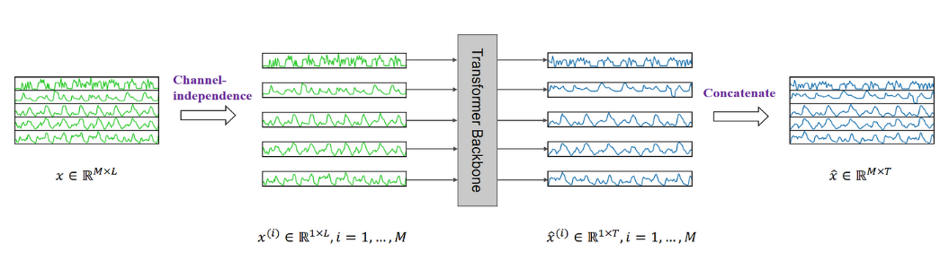
Figure (a): Overview of the PatchTST model

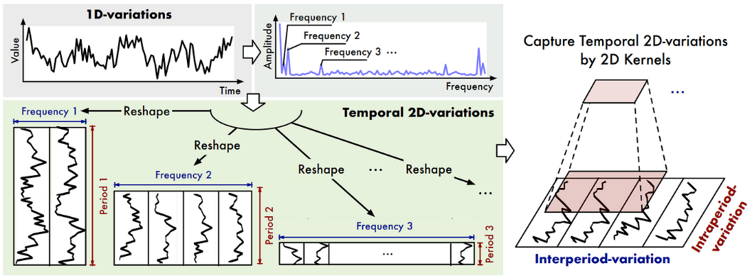
Figure (b): Overview of TimesNet architecture
- Building of the LSTM model
In the context of this study, data are included from the GISS Surface Temperature (GISTEMP) analysis and the global component of Climate at a Glance (GCAG) and we are expected to only predict the global monthly mean temperature.
For performing that, we choose the LSTM model which is a recurrent neural network (RNN) for capturing long-term dependencies. Here are the major steps that we followed for achieving the task:
-Data preparation which involves data cleaning for handling missing values or changing some data types, but also, normalization of the features.
-Feature engineering by adding some lag-features for better identifying patterns and relationships between variables even though we just have one variable, and then split data into train and test.
-Design the model architecture and perform the hyperparameter tuning which consist of the choice of number of layers, the number of units, the percentage of dropout for dealing with overfitting, dense layer, the learning rate, the loss function to minimize, the optimizer and finally the number of epochs and the batch size.
-After that, we trained the model and test it for predicting the global mean temperature.
-The last step was the evaluation of the performance of the model and we used the Root Mean Squared Error (RMSE). The results are presented in the next section.
- Discussion and results
In this section, we are going to dress a board which present the architecture of the model that we built but also the techniques that we implemented for enhancing the model. We summarize the results and shortly comment them.

MODEL | Model 1:  LSTM | Model 2:  LSTM | Model 3:  LSTM/BiLSTM
ARCHITECTURE | -1 LSTM layer with 100 neurons  -Dropout 20%  -Dense layer  -Mean Absolute Error (MAE) as Loss function and Adam as optimizer (it is an adaptive learning rate approach)  -Epoch=70; Batch size=50 | -1 LSTM layer with 100 neurons  -Dropout 20%  -Dense layer  -Mean Absolute Error (MAE) as Loss function and Adam as optimizer (it is an adaptive learning rate approach)  -ReLu as activation function  -Epoch=60; Batch size=45 | -1 LSTM layer and 1 BiLSTM layer with 50 units each  -Dropout 20%  -Dense layer  -Mean Absolute Error (MAE) as Loss function and Adam as optimizer (it is an adaptive learning rate approach)  -Epoch=70; Batch size=50
CHANGES | None | -Decreasing of the number of epochs (70 to 60) and batch size (50 to 45)  -Adding of an activation function (ReLu) | We switched from 1 layer of unidirectional LSTM to 2 layers (First is Bidirectional LSTM and the second is a unidirectional LSTM) and distributed 50 units to each layer.
RMSE | 0;09 | 0;19 | 0;19
Table 1: Architectures of models and summarizing of results

For improving our first model, we experimented two cases: In the first case, we can notice that for the model 2, we adjusted some hyperparameters because they can directly affect the performance of the LSTM model. It’s important to set well the number of epochs because a smaller number will lead to an underfitting, otherwise we will not have a good generalization performance, precisely a case of an overfitting. In the same way, the batch size can also affect the accuracy of the model. We highlighted the importance of the hyperparameter tuning step when we build a deep learning model for achieving good results.
In the second case, for the model 3, by adding a BiLSTM layer, we captured past and present data information simultaneously so the output is more meaningful and the prediction accuracy is highest. Setting up a good architecture of the model is also important for achieving a good performance of a deep leaning model.
- Conclusion
To conclude, we can notice that LSTM model is performing well for time series forecasting. However, we can enhance its execution by fine tuning hyperparameters or combine it with a Bidirectional LSTM.
In a future work, we could test a transformer based-model for comparing it to our present work and see the results.

Yuqi Nie , Nam H. Nguyen , Phanwadee Sinthong, Jayant Kalagnanam; ‘’ A TIME SERIES IS WORTH 64 WORDS: LONG-TERM FORECASTING WITH TRANSFORMERS’’; ICLR 2023; https://arxiv.org/pdf/2211.14730.pdf
Haixu Wu, Tengge Hu, Yong Liu , Hang Zhou, Jianmin Wang, Mingsheng LongB; ‘’ TIMESNET: TEMPORAL 2D-VARIATION MODELING FOR GENERAL TIME SERIES ANALYSIS’’; ICLR 2023; https://arxiv.org/pdf/2210.02186.pdf

